UBUNTU COMMANDS 2

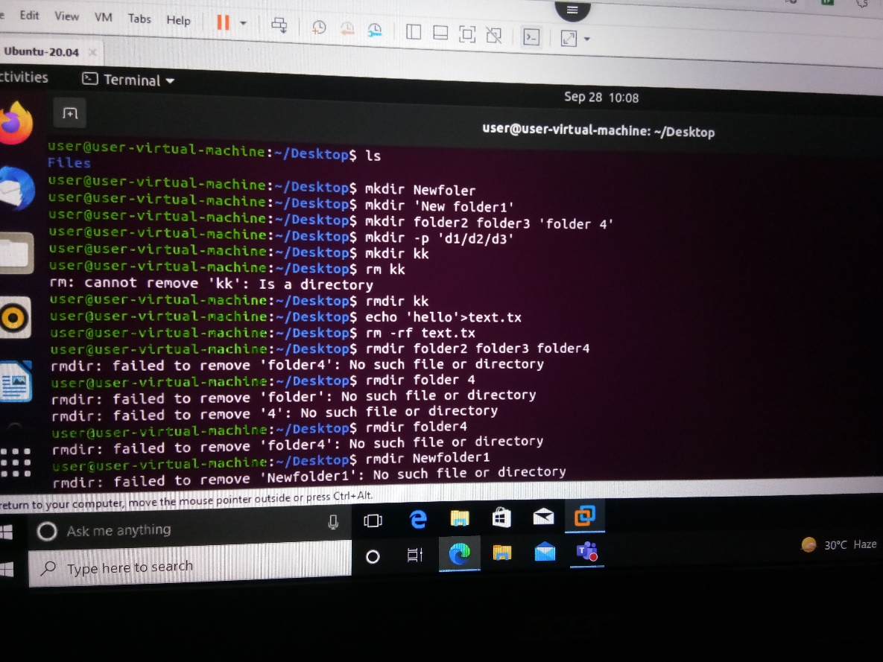

Mkdir Newfolder: to create directory

Mkdir ‘ New Folder’:to create folder with space between the naming of folder

Rmdir: remove folder

Rm: remove folder

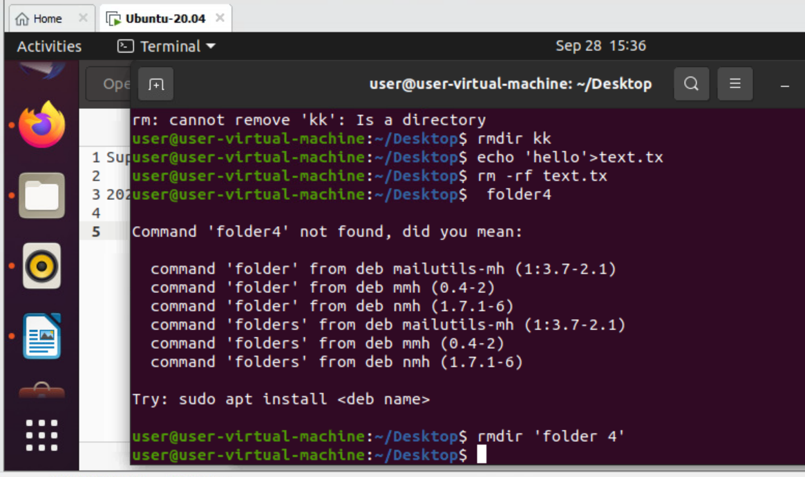

Rm -rf d1- remove the nested folder contain

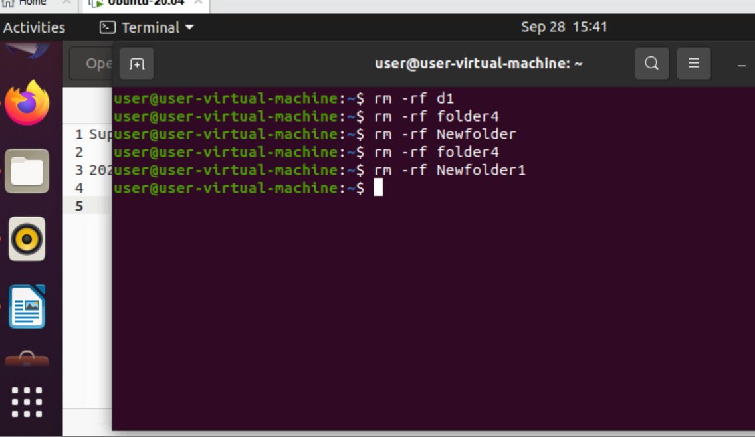

Mkdir folder{1..10}: folder1 …..folder10

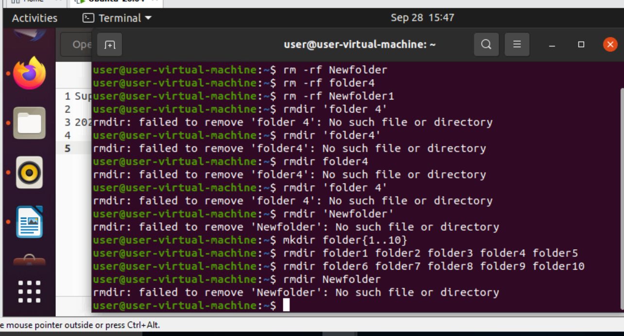

Touch: use to create empty folder

Rm \*: use to delete all the folder in single go

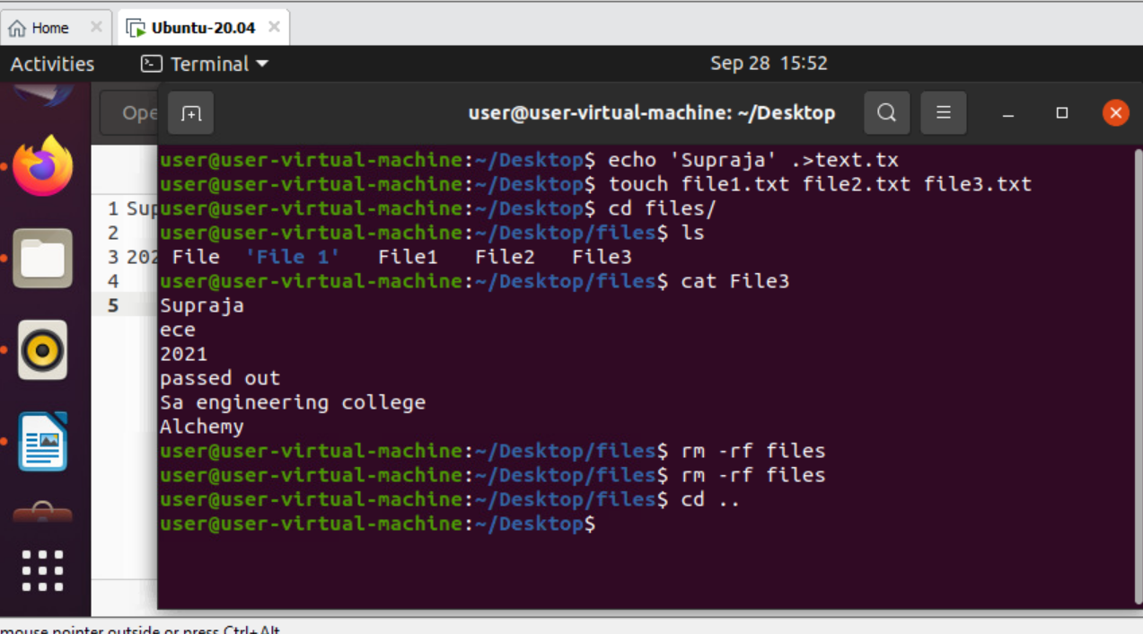

Cp file1 file2: copy file1 data into file2

Cp -i file1 file2: it will ask whether to overwrite or not the content of file.

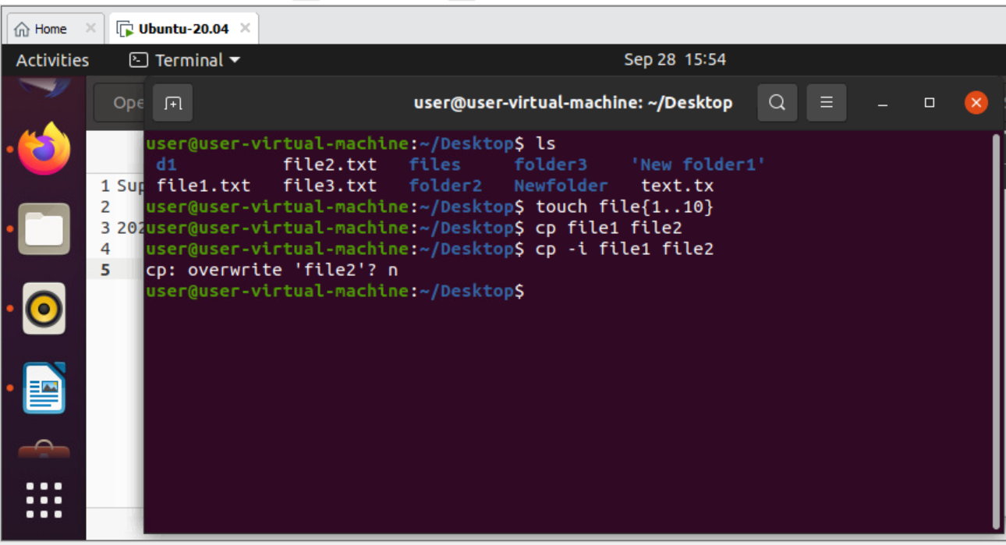

Cat file1 file2 file3: copy content of file1 and file2 in file 3.

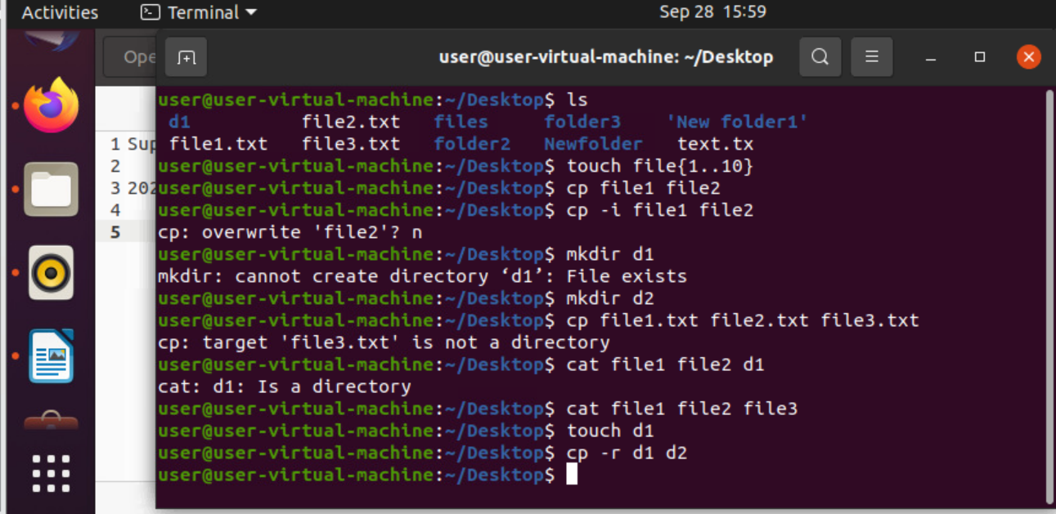

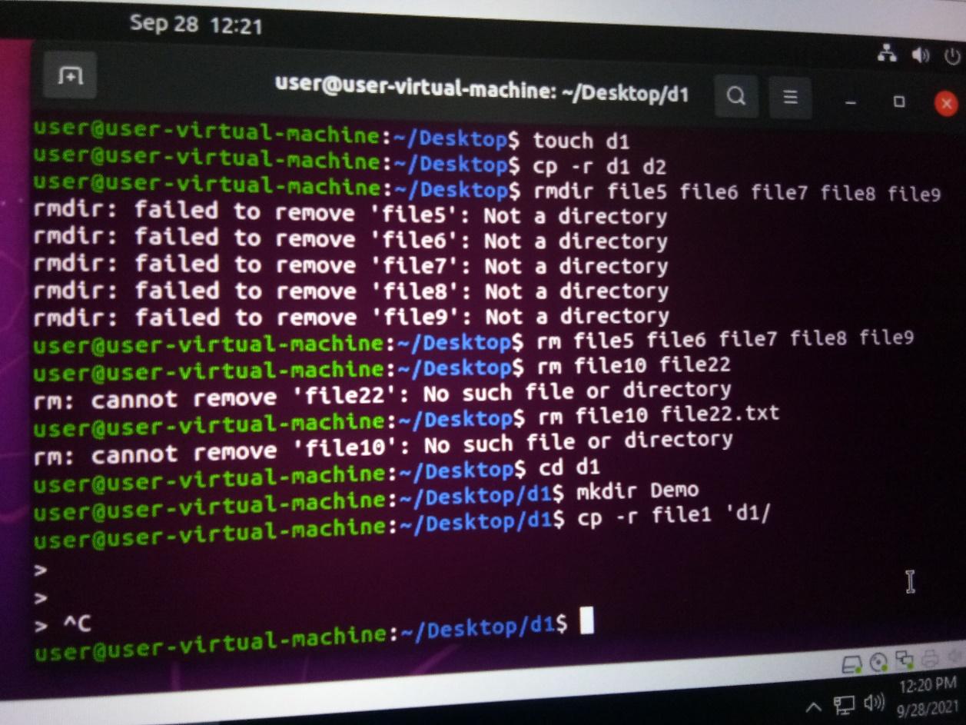

Cp -r d1 d2: It will copy all data from d1 and copy it into d2.

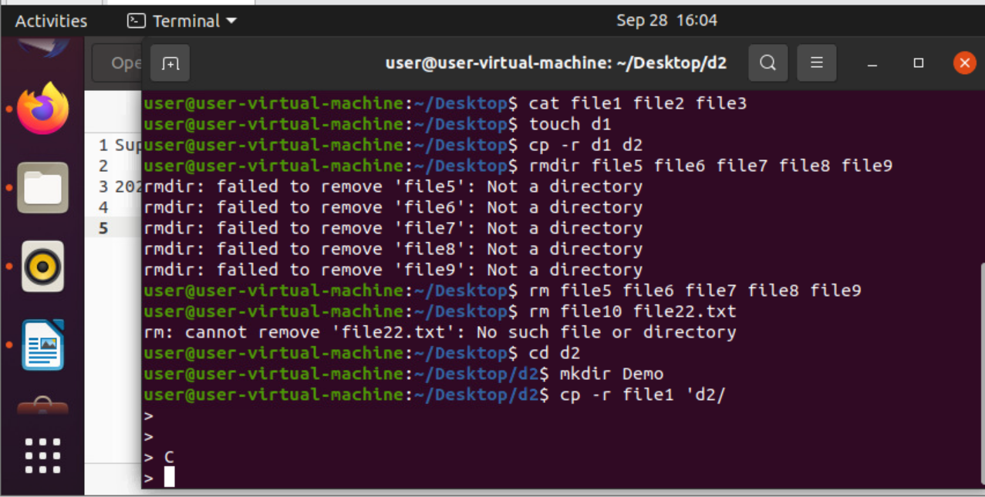

Mv -b Demo folder: create backup of Demo

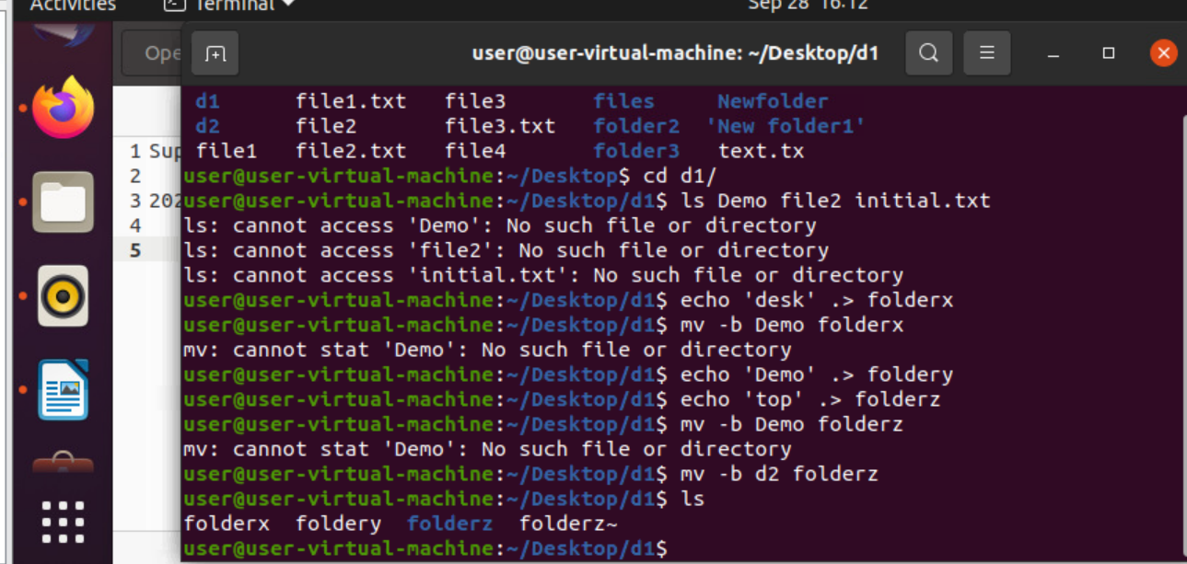

Sort file1: sort the file

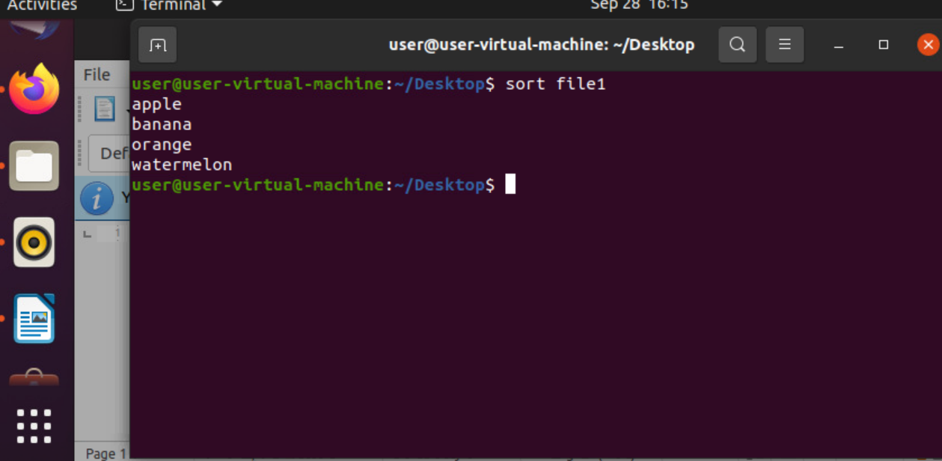

Sort -r sorted.txt: reverse the sorted list

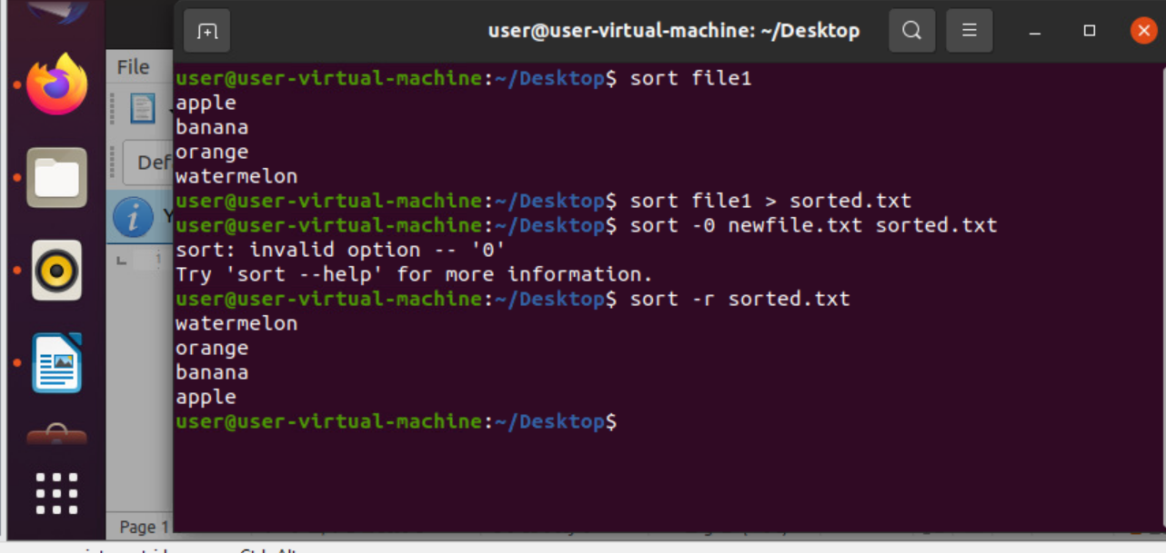

Sort -n number.txt:sort the numerical value

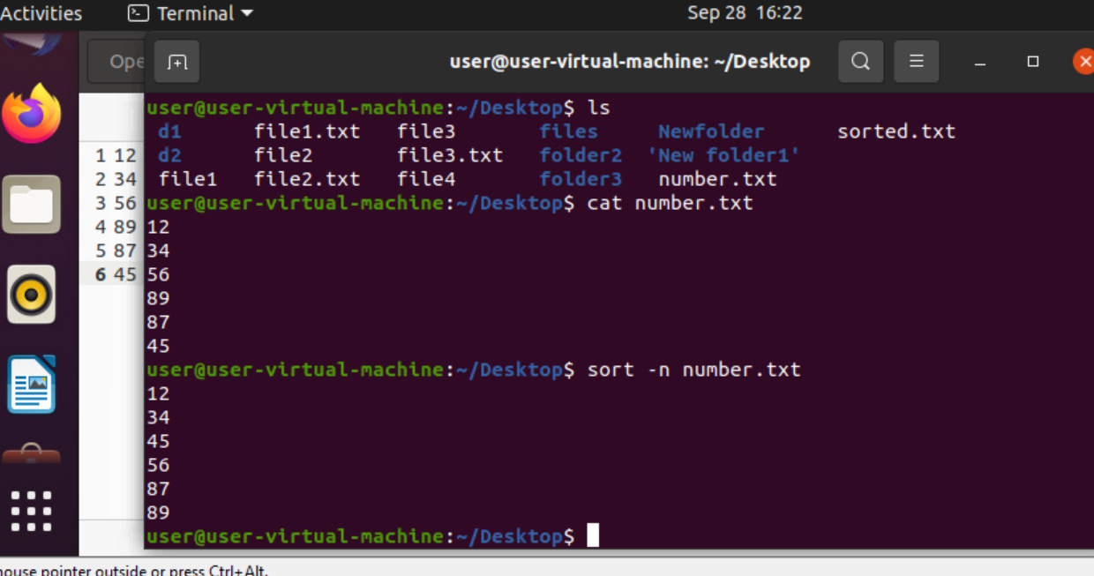

Sort -nr number.txt: sort the number and reverse it.

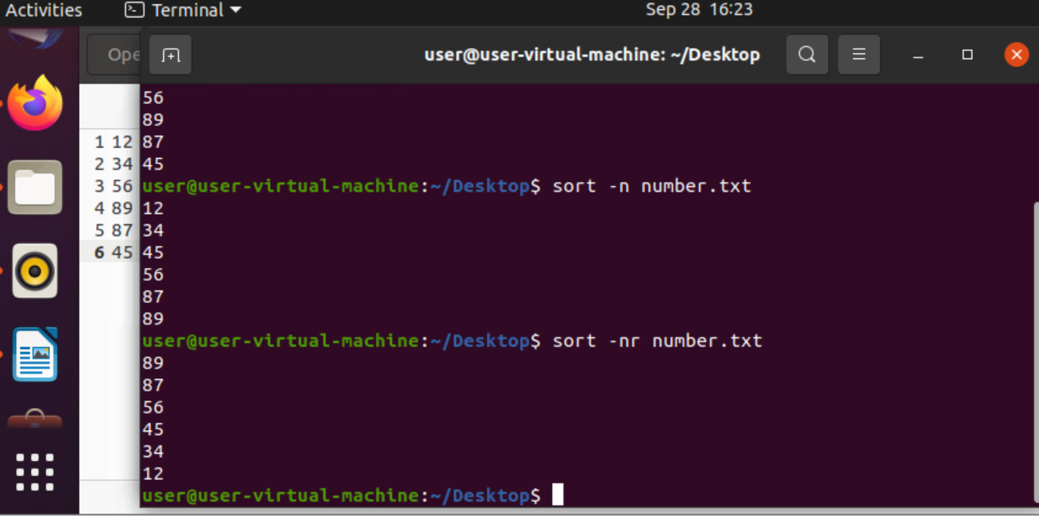

Sort -nk2 number.txt: sort the second column.

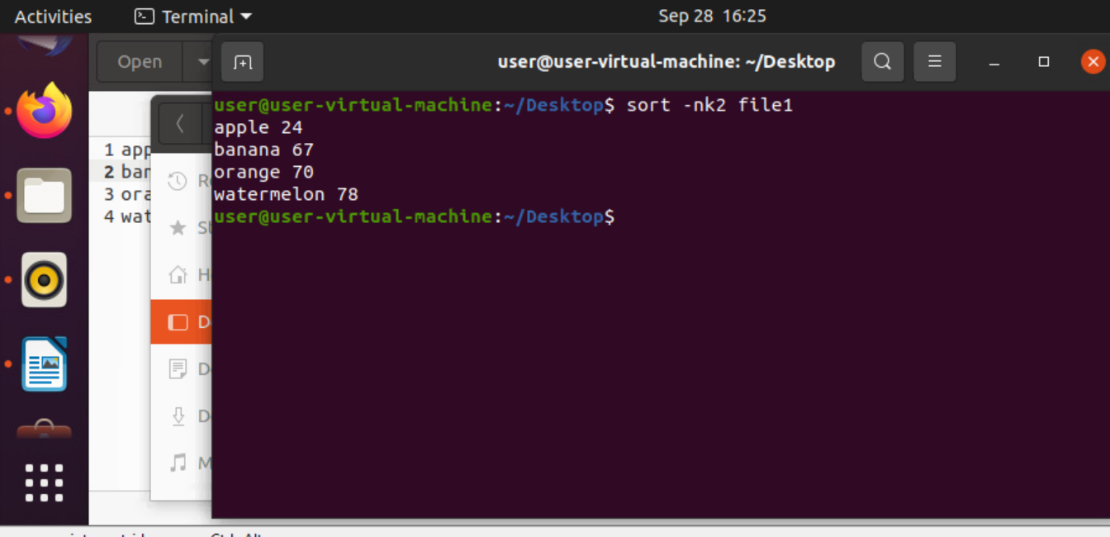

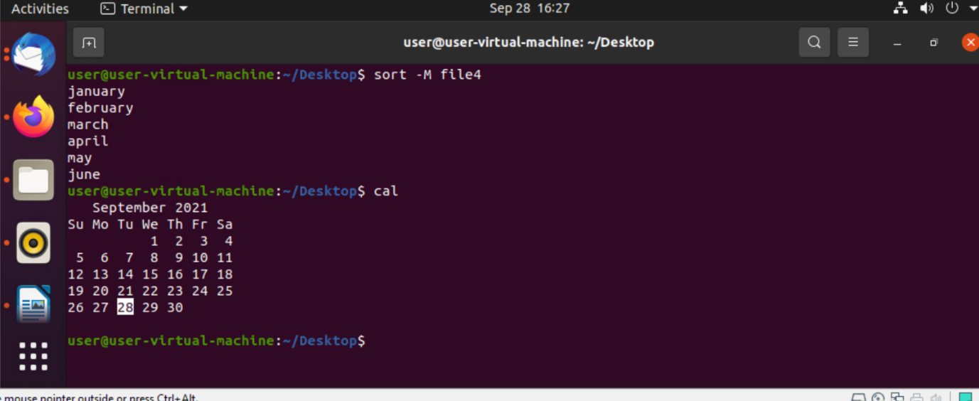

Sort -M newfile.txt: sort the month

Cal: display calender of recent date.